**Git & GitHub Note**

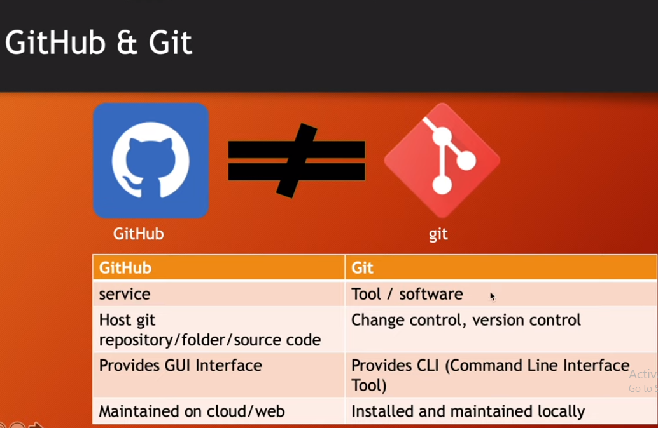

1. Git instal check = git –version
2. User name set = gir config -- global user.name “Saraor-Suzan”
3. Email set = git config -- global user.email [saroarhossansuzan@gmail.com](mailto:saroarhossansuzan@gmail.com)
4. User & email name check = git config –list
5. Cd desktop (enter) cd notes (enter) day1.txt
6. When add some text = git add day1.txt
7. Status check = git status
8. When you add more data you can check = git diff
9. When you remove data = rm --recached day1.txt
10. Back to notes = cd ..
11. When you need Restore text = git restore day1.txt
12. Changes to be committed = git commit -m "day1 data is added"
13. Check commit history = git log
14. When add + commit (same time) = git add . && git commit -m "day3 data is added"

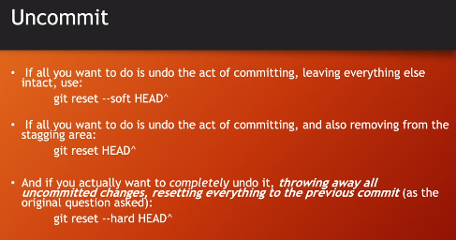

1. Different details = git log --oneline
2. More details = git show +(git log --oneline er id copy paste)
3. Remove txt = git checkout + txt id (copy paste )
4. If you back removable txt = git checkout master
5. 